Contents

Overview …............................................................................................................................................. 2
Architecture …......................................................................................................................................... 3
Data Design …......................................................................................................................................... 4
Data Dictionary............................................................................................................................. 4
User Interface …....................................................................................................................................... 5
ATM Interface ….......................................................................................................................... 5
Web Interface …........................................................................................................................... 6
Team Assignments …............................................................................................................................... 8
Timeline …............................................................................................................................................... 8
Revision History ….................................................................................................................................. 9

Overview
For our project, we decided to implement a banking system. We plan to support Savings, Checking and several types of loans within the application. We will have two types of User Interfaces currently planned: one is an ATM and the other is a web based banking interface. The user side of the application will invoke RMI to call methods on the Server.

All the user data (names, account numbers, etc) will be stored in a MySQL database. This database will be accessible by the Server side of our program. There will be multiple clients connecting simultaneously to the server over a network connection. The server will parse and analyze user input, query the database, and return output back to the user.

Advanced functionality at the ATM will consist of the ability of users with various loans to make payments to those loans, monitor the existing balance on the loan, and withdraw cash from existing credit lines provided through said loans. From the web UI the user will be able to view account and loan transaction histories and transfer funds. Authentication at the ATM will consist of an account or card number and PIN, and also at the web page (username and password).

We have chosen to use a MySQL database because it is free, and can handle synchronicity by itself (very important for any database, but especially for a bank).

The bulk of the 'Business' portion of our application will be built using Java and RMI to facilitate remote access. The web interface will use Java Server Pages and probably PHP.

Architecture
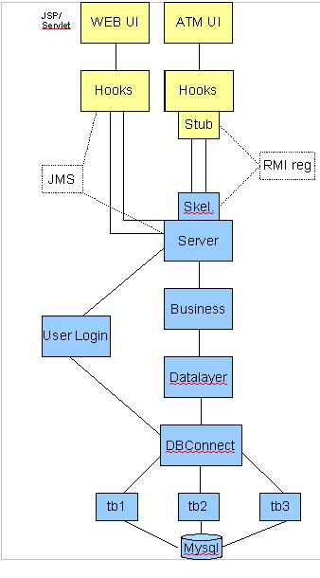

Architecture Notes:
- The DBConnect and tb1-3 elements will provide access to the database and function as our DBMS.
- The Data Layer classes/objects will interface between the main portion of the server and the DBMS.
- The Business and Authentication (not shown) elements will perform the main ‘heavy lifting’ functions on the server side of the application.
- The Server and skeleton classes will provide networked access to the server side of the application.
- JMS and RMI Registry will be used to facilitate communications between the client and server sides of the application.
- The “hooks” and stub class elements exist to provide the connectivity portion of the client side of the application.
- The Web UI and ATM UI elements shown are place holders for the GUI the user will interact with on deployment.

Note: This is a ‘first blush’ take on our class/object structure, few of these elements have actually been designed and as such this diagram is subject to change (will be noted in the revision history).

Data Design

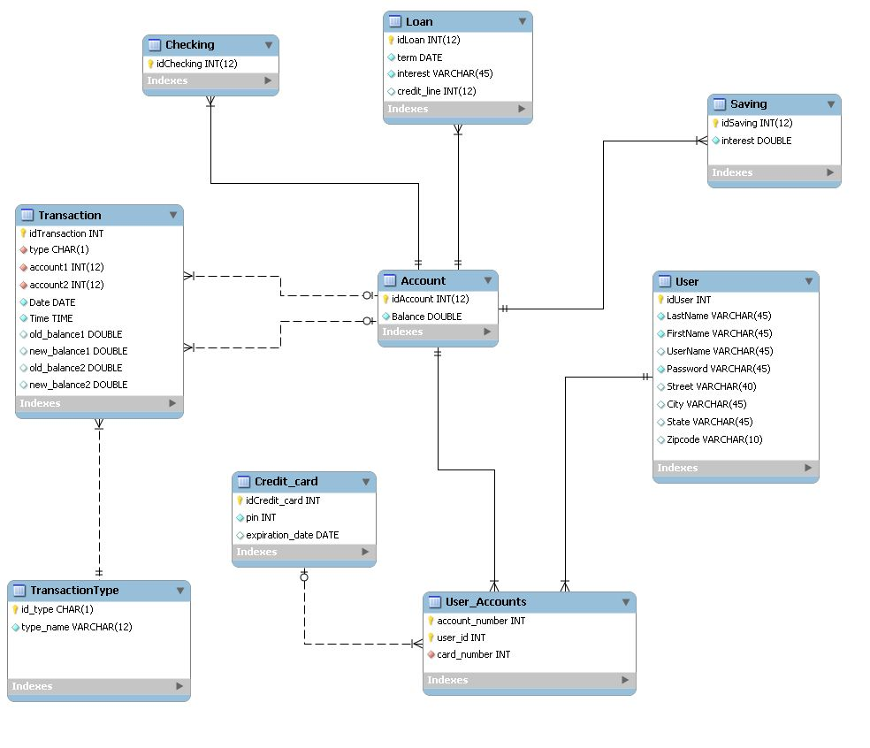Data Dictonary

We will be using a MySQL database in order to provide data persistence functionality to our banking application. The database will be stored server-side at the same physical location, and the server will use standard ODBC drivers to connect from the program to the database to send queries and retrieve the results.

Our current design calls for three main tables:
- a table of users;
- a table of accounts;
- a table of checking accounts;
- a table of saving accounts;
- a table of loans;
- a table of user accounts;
- a table of credit cards;
- a table of transactions;
- a table of transaction types.

- pin –

The users table will contain the following columns:
- idUser – integer, starts from 0 and counts up, used as the primary key
- FirstName – 1{character}45, first name of the user
- LastName – 1{character}45, last name of the user
- UserName - 1{character}45, username of the user (used for the website)
- Password – 1{character}45, used as an identification code for web banking transactions
- Street – 1{character}120, street address of the user
- City – 1{character}45, city the user lives in
- State – 2{[A-Z]}2, 2-letter state code for the user
- ZipCode -- 1{character}10, the zipcode

- cardnumber – 12{[0-9]}12, the ATM card number of the user
The accounts table will contain the following columns:

- idAccount – 12{[0-9]}12, the account number of the user, used as the primary key
- Balance – double, the current balance of the account or the loan

It has three subtables, checking, savings, and loans, used for checking accounts, savings accounts, and loans respectively.

The savings table has one additional column, the column are:

- idSaving - 12{[0-9]}12, the account number of the user, which is the primary key and a foreign key from the Account table
- interest – double, the current interest rate (nominal APR) of the account
The loan table has five additional columns, the columns are:
- idLoan - 12{[0-9]}12, the loan number of the user, which is the primary key and a foreign key from the Account table
- Term – date, when the loan is due
- Interest – double, the current interest rate (nominal APR) of the loan
- Credit_line – double, the current credit line remaining in the loan for some loan types

The checking table has no additional column:
- idChecking - 12{[0-9]}12, the checking number of the user, which is the primary key and a foreign key from the Account table

The credit card table is used to represent a credit card, the columns are:
- idCredit_card - Integer, the credit card number used as a primary key
- Pin- 6{[0-9] }6, used as an identification code for ATM transactions
- ExpirationDate – the date that the credit card expires

The many-to-many relationship between accounts, users and credit card is mediated by a user_accounts table, which takes id from users, account_number and credit card number from the respective tables as foreign keys and associates each triplet in a row, allowing for one account to have multiple users (in the case of married couples, etc.) or one user to have multiple accounts (for example, checking and savings). There is only one credit card per couple (user, account).

The transactionType table contains the type of transactions available in our bank, three types are available (withdraw, deposit ans transfert from accounts).The columns are:
- Id_type – 1{character},the first letter and identificator of the transaction, used as a primary key
- Type_name – varchar(12), the type name of the transaction.

The transactions table contains a history of all transactions which have taken place within the bank’s system, and will contain the following columns:
- idTransactions – integer, starts from 0 and counts up, used as the primary key
- type – 1{character}45, the type of transaction, foreign key from the table TransactionType
- accountOne – 12{[0-9]}12, foreign key from accounts, the first account involved in the transaction
- accountTwo – 12{[0-9]}12, foreign key from accounts, the second account involved in some kinds of transactions. Left null in others.
- date – date, the date on which the transaction occurred
- time – time, the time at which the transaction occurred
- old_balance1 – double, the amount of money before the transaction for the account1
- old_balance2 – double, the amount of money before the transaction for the account2
- new_balance1 – double, the amount of money after the transaction for the account1
- new_balance2 – double, the amount of money after the transaction for the account2

User Interface
ATM
Our ATM interface is currently being designed. Below we have several mock-ups of the purposed screen layouts.
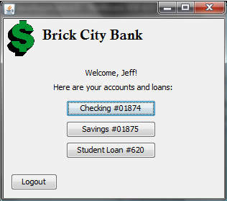
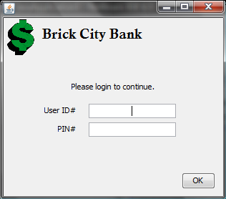
The Log-in Screen and Welcome Screens

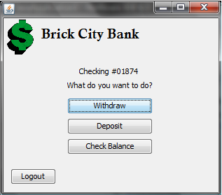
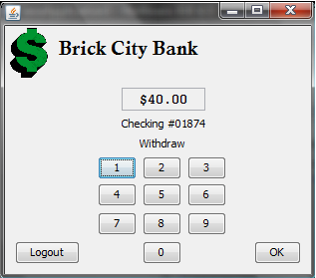
A sample checking account and withdrawal Screen

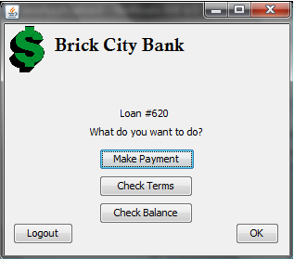
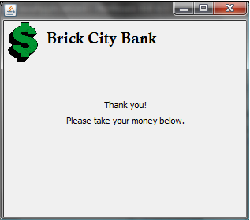
The Loan and Exit screens

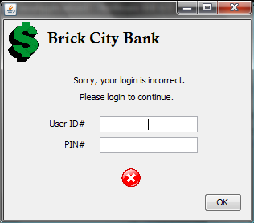
The incorrect log-in screen

Web Interface
Currently the web interface for our system has yet to be designed. This section will be updated as needed throughout the design and implementation phases.

Team Assignments
Jeff Mueller - User Interface design and Implementation
Caroline Malnoe – Connectivity Implementation
Louis Duke – Documentation, Quality Assurance and core program implmentation
William Manville – Data layer and DBMS Implementation
Ira Mertes – Database Design and Implementation

Timeline
Below is our proposed timeline for phase 2 of the project.
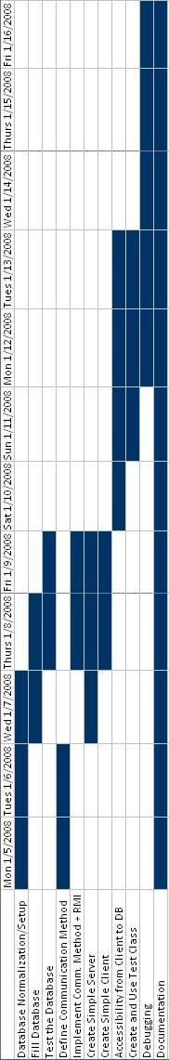

Revision History
Version | Date | Modification
Version 1.0 | 12/14/2008 | Initial design document created
Version 1.1 | 1/12/2009 | Database design modified :

